**Nutrition Guide**

**USER NEEDS AND REQUIREMENTS REPORT**

**November 2, 2018**

By:

Matthew Mahabeer – 620097948

Matthew Patterson – 620095960

Daniel Hughes – 620099840

# **Table of Contents**

Abstract

Overview

Design Goals

User Characteristics

Important Characteristics of Task Performed by Users

Description of Important Characteristic Of Task Environment

Analysis of Existing System

Larger Social and Technical System

Description and Justification of Data Collected

Usability Criteria

Appendix

# **Abstract**

Poor eating habits include under or over eating, not having enough of the healthy foods we need each day or consuming too many. These unhealthy habits affect our nutrition intake.

How can poor nutrition affect us?

Poor nutrition can impair our daily health and wellbeing and reduce our ability to lead an enjoyable and active life. In short term, poor nutrition contributes to stress, tiredness and our capacity to work. In long term, it can contribute to illnesses and other health problems.

One reason poor nutrition is so widespread is because of the global lack of knowledge of what a balanced nutrition consists of. Many people have the means to have a balanced nutrition but don’t know how to achieve it.

For this reason, the objective of the project is to develop an interactive application that will help users to achieve a balanced nutrition by enlightening users on the amounts of each nutrient they should aim to take in to have a better life!

For maximum efficiency the application will focus on:

* Simplicity – Users should find the application fairly simple to use.
* Usefulness – The application should provide information that will really improve nutrition
* Efficiency – Information provided by the application should show immediate effects
* Consistency – The system should perform with great stability throughout its entirety

# **Overview**

Healthy eating means eating variety of foods in the right proportions that give you the nutrients you need to maintain your health, feel good and have energy. These nutrients include protein, carbohydrates, water, essential acids, vitamins and minerals.

The application focuses on allowing users to be able to view the nutritional content of the foods they are eating or intend to eat. Unlike other nutritional guides, this application will not try to tell users what to eat. The application will reveal the contents of a balanced nutrition and indicate that that is what is the user is trying to achieve. Foods will be accessible by a simple search which will display the contents of that food along with the suggested amount of daily intake.

# **Design Goals**

The design of this is to make user interaction as simple as can be. Efficiency is also a major key. This will be carried using design to techniques to achieve the design goals which include:

* Efficient searching – Providing suggestions while users search along with accurate results
* Efficient results – The database should contain most basic foods that users might search for
* Transparency – Clear navigation guides throughout the application.
* Eye friendly – Colors used to style the application should be friendly on the eye

# **User Characteristics**

The interactive application will be used by users who are interested in achieving a healthier lifestyle through nutrition. The analysis of user characteristics revealed that other nutritional programs aim to reduce calorie intake instead of aiming to achieve a balanced nutrition. This is not usually the healthiest way with respect to food consumption, therefore the system will focus strictly on maintaining a balance diet which is the healthiest way to live. The system will ask for monthly ratings from customers in order to measure its efficiency and will incrementally improve using its feedback. The system will assist new users to become familiar with the use of pop up icons indicating important features.

The application is expected to serve users on Android devices. To this end, users are expected to have a general knowledge of Android devices and how to utilize them. Users are expected to also have general abilities, such as the ability to read and perform proper motor skills. In addition, they must have some capability to prepare their own meals as may be dictated/recommended by the app. The users must also have the ability to respond to prompts given by the app and take initiative to guide themselves to a healthier lifestyle; the intention of the app itself.

# **Important Characteristics of the Task Performed by Users**

The app will perform a number of essential tasks which aims for user satisfaction. Firstly, there will be security checks performed. This could be performed by signing up to use the app by providing the app with their personal information, such as age, weight and height, that will be kept solely within the app’s data and not shared anywhere. User information will only be used to greet and address them politely throughout the application and to maintain a profile of their diet. This data will be used to prepare a plan to help the user maintain a healthy diet. Alternatively, if the user is already signed up, then they will be able to simply sign into their profile and immediately access the main menu.

Once signed in, the app will provide a menu containing possible tasks that they could attempt to fulfill such as reading tips for a better diet or searching for nutrients that are essential to achieve a balanced nutrition. Choosing one of these nutrients will reveal a list of foods that contain these nutrients and the along with the nutrient levels. These tasks support the user with searching for proper foods to eat/prepare for better eating.

The possible tasks also allow a user to join a community of other users. The community is a space where the apps users can communicate and help one another through encouragement, sharing tips or recipes.

For users who are already considering having something specific to eat, they can simply search up that food item in our database and view the nutritional contents of it. For some users who need more guidance, a list of fully prepared meals will be available in the application’s suggestions section.

A record of their nutrient intake will also be kept for all users. The importance and usefulness of each nutrient can be found in their (nutrient) respective profiles. Users will have the option to select what they had to eat, then it will be subsequently linked to their history and they will be able to see an estimate of how much of each nutrient they had on that particular day.

# **Important Characteristics of Task Environment**

Task environment refers to the area that the user will interact with to complete tasks. The environment that will be built within this application is a menu driven graphical user interface (GUI) software. This is not an application that is expected to be used for an extended period of time throughout the day, therefore the aim is to make navigating through the application as quickly and as logical as possible. The best way to achieve this is by implementing menus and quick access icons located on a fast-access bar. The application is a completely independent application that needs no external factor to function. The only boundary of the physical environment of the software is memory on the device that it is being used on as the users’ personal logs will be updating when they add new food items or update their nutritional intake. The software is completely functional once there is enough memory to host it.

**Analysis of Existing System**

# Carb Manager - Keto & Low Carb Diet Tracker

Carb Manager is a free application any Android User can download and use to track nutrients consumed, with a focus on Carbohydrates. The user is able to add foods that they have consumed and the application will track them to let the user know what each food item gives and the total nutrients consumed for the day.

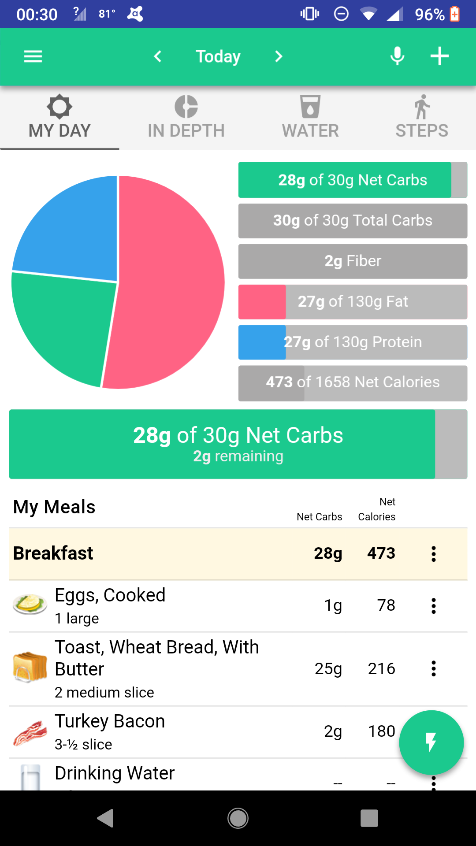

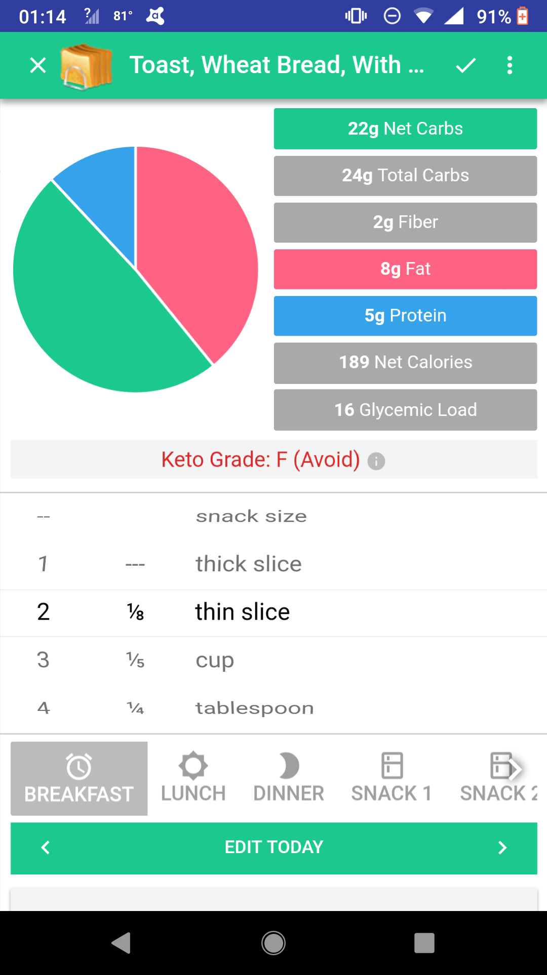

The user is also able to make their own notes for recording purposes. The main page also offers suggested recipes but they are only available after purchasing a plan.

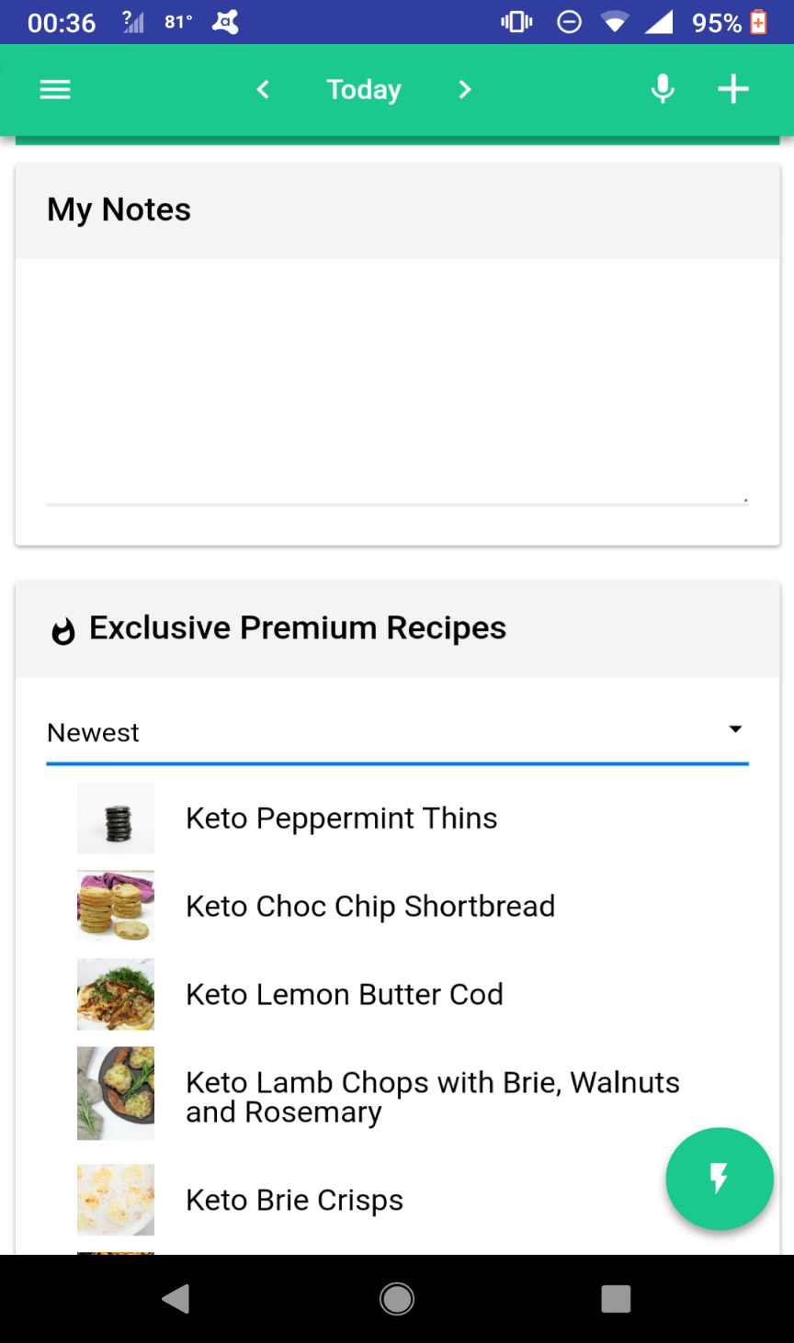

Carb Manager also gives users the ability to search for and save exercises that they are interested in doing for better health. This is an added benefit to the app’s original purpose which only helps the user to burn the Carbohydrates that they may have taken in prior.

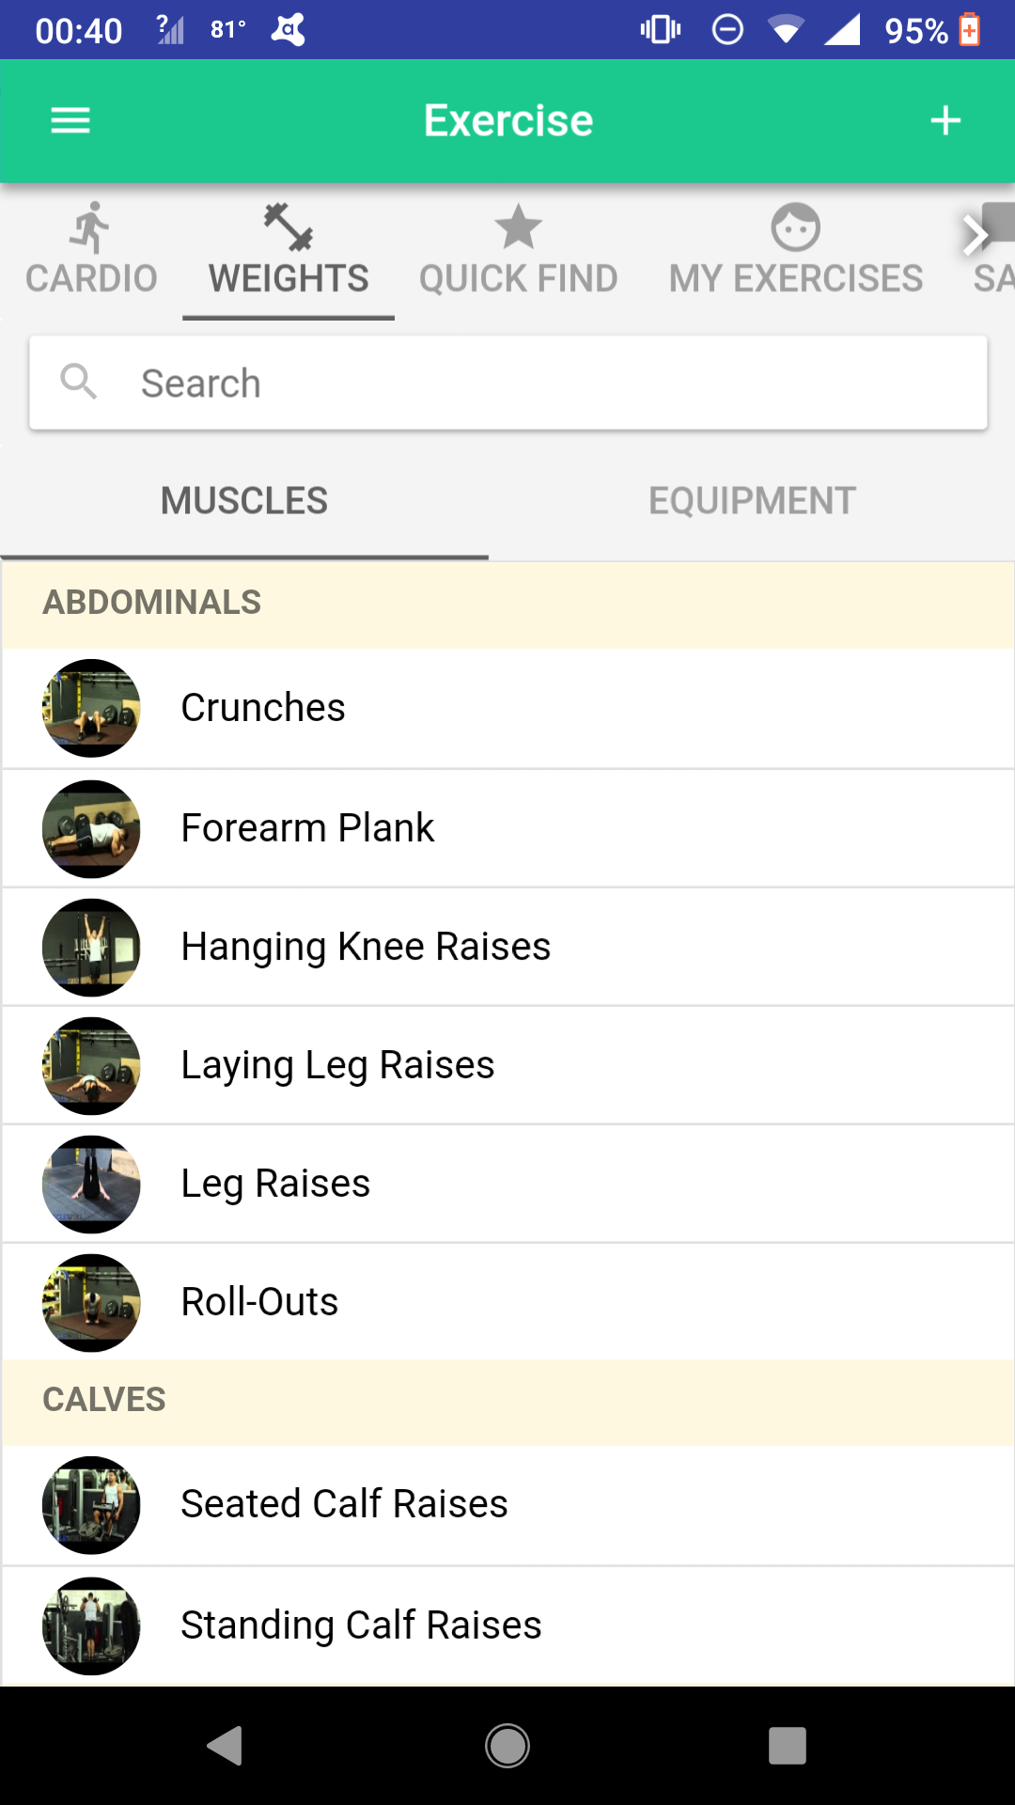

Users are also able to save data regarding their measurements, such as weight, height and arm size.

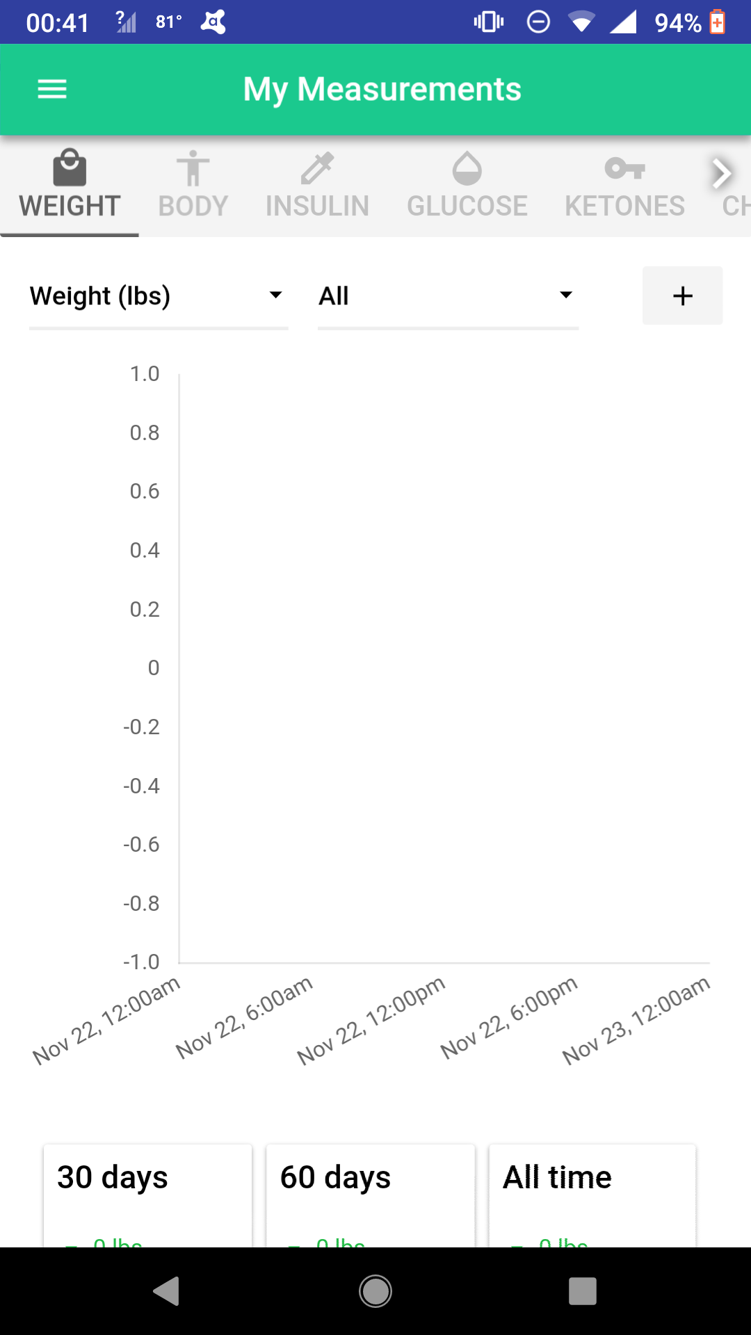

The user is able to manage their settings at any point they wish to by simply navigating to the Settings tab and editing the data previously saved.

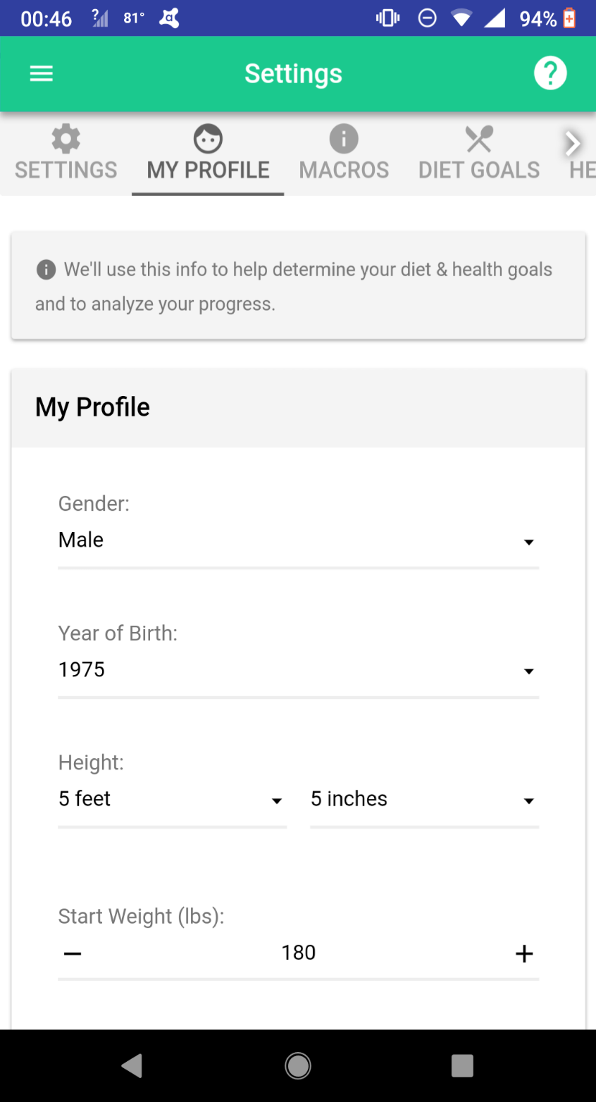

The main issue presented by the app is the lack of features available without buying a premium deal. Users also reported saying that they believed the app looked unappealing.

<https://play.google.com/store/apps/details?id=com.wombatapps.carbmanager&hl=en>

# Lifesum: Food Diary, Macro Tracker & Diet Recipes

This application features:

DIET DIARY & NUTRITION TIPS

Lose weight with your personal diet plan. Take our test to discover which one is the right one for you. From keto diet recipes to low carb & everything in between, we have the right diet diary & diet tips for your goals.

MEAL PLANNER & RECIPES

Healthy recipes help you stick to your plan. Stuck in a keto diet rut? Explore recipes to beat the sugar cravings or search for low carb snacks. Can’t decide what to have? Check out the meal planner for ideas. Healthy eating is easier than you think!

CALORIES & FOOD PLANNER

Calorie counter & food tracker functions help you see your calories & nutritional values at a glance. Did a workout today? Go premium & sync Lifesum with FitBit, Runkeeper, Moves & other fitness apps.

FOOD DIARY & MACRO TRACKER

Macros mythbusting. It’s easy with our macro tracker - make sure you reach the right type of energy composition. Simply scan barcodes for macros & calories, or enter manually.

<https://play.google.com/store/apps/details?id=com.sillens.shapeupclub>

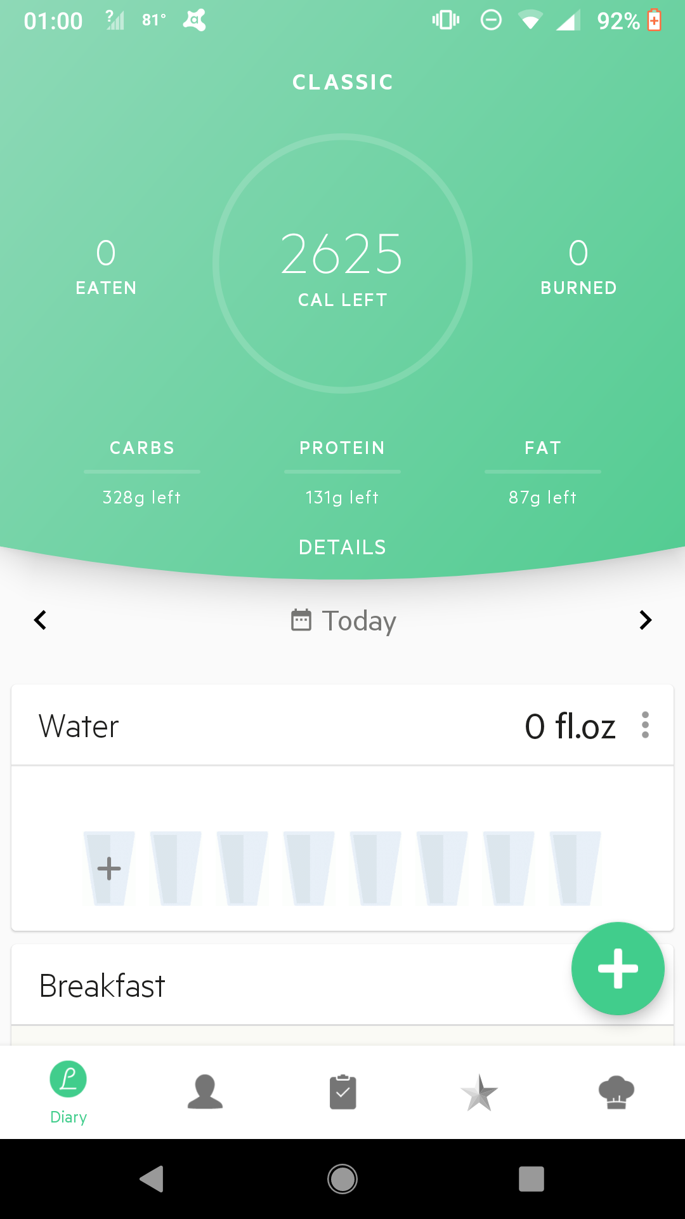

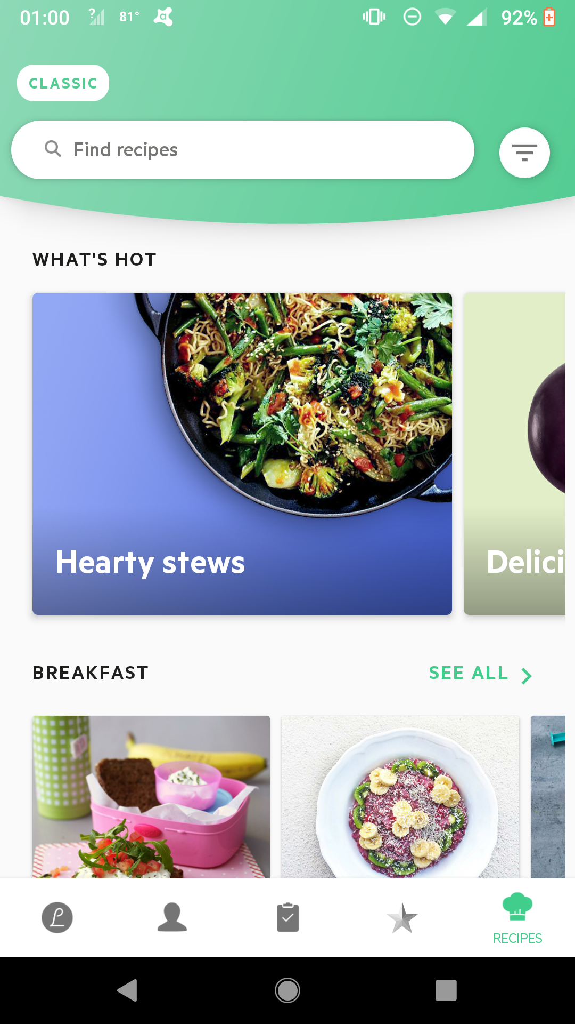

# MyNetDiary

This application was designed for diabetes type 1, type 2, pre-diabetes and gestational diabetes.

This app helps you understand and control all aspects of diabetes. It shows you the “big picture” of your blood glucose factors by counting carbs in the food you eat, recording medication intake, exercise and everything else you want to capture about your condition.

The app coaches you on losing weight and staying fit. You will learn to eat better and become more active with app tips. The app reveals what really affects your blood glucose when you start changing your lifestyle. We hope your diabetes management story will be a success empowered by our tracker

This app is an educational tool, it is not a medical device, it is not a substitute for a medical device or medical care, and it does not provide diagnosis, cure, mitigation, treatment, or prevention of any disease. If you have questions or concerns about individual health matters or management of your conditions, please consult your healthcare team.

<https://play.google.com/store/apps/details?id=com.fourtechnologies.mynetdiary.ad>

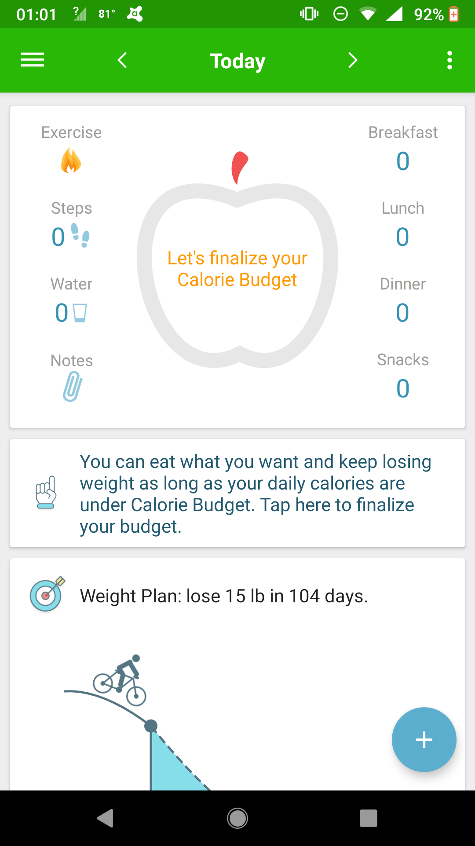

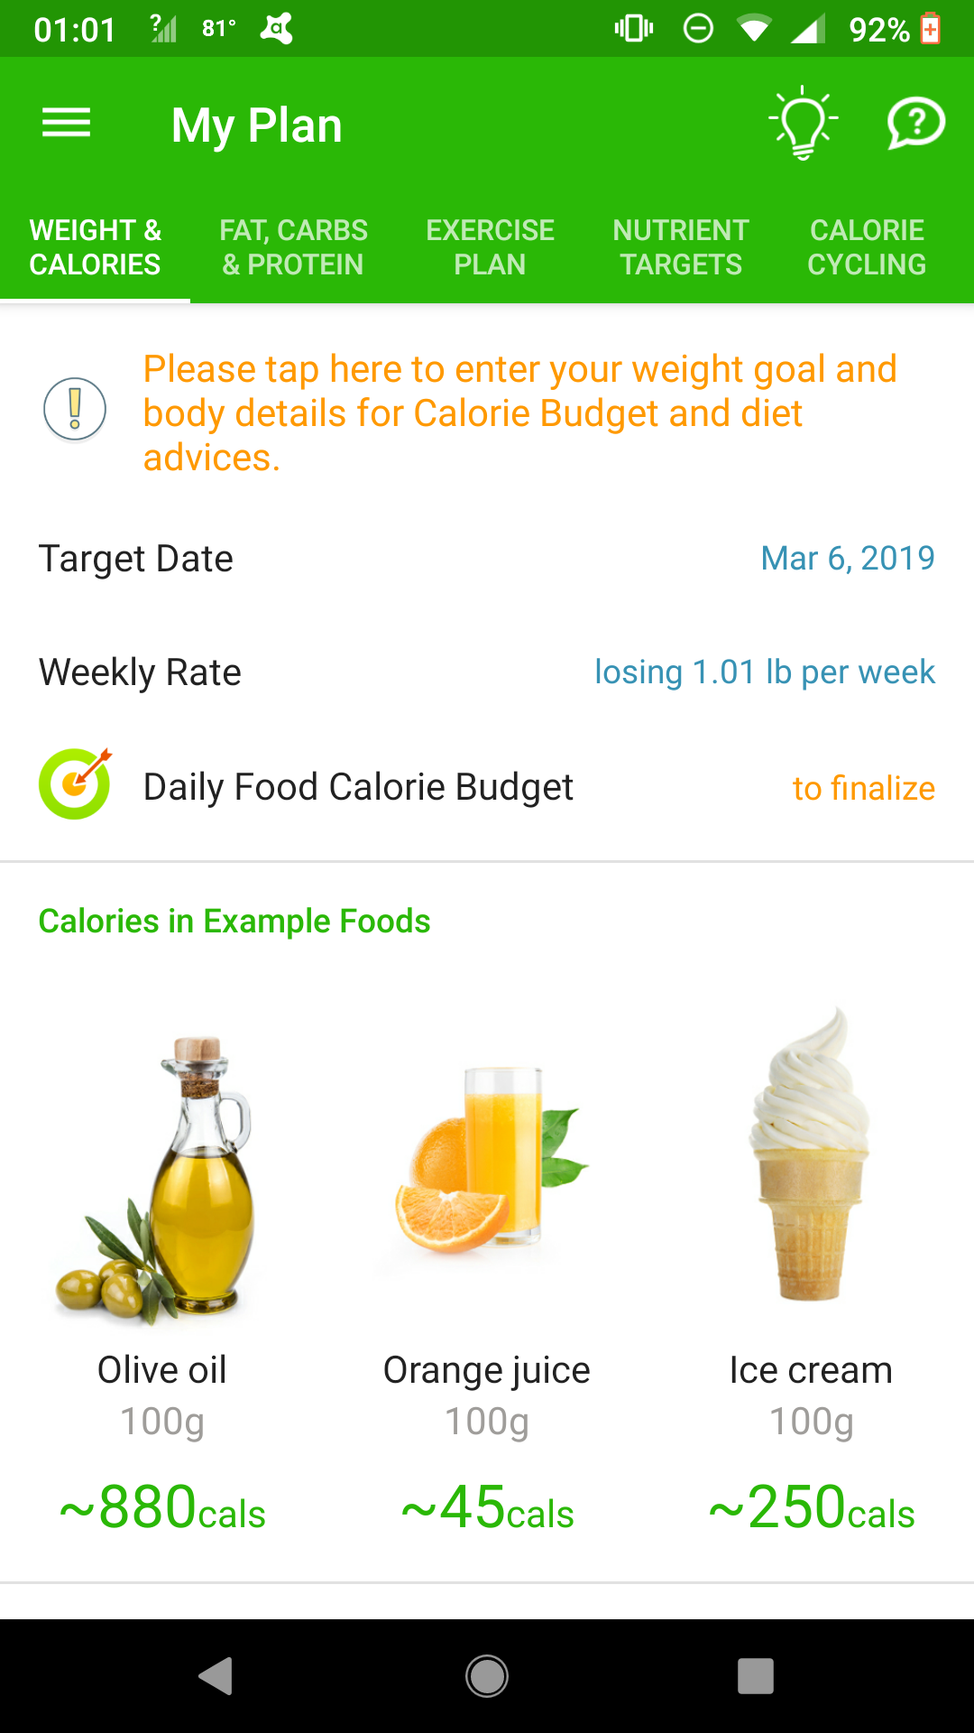

**Larger Social and Technical System**

The application being developed will play an integral role in helping users to become healthier by allowing them to understand how a balanced nutrition is achieved. To be more specific, the application will have a tally system for users to keep track of the amount of nutrients they consume day to day. Nutrition should be important to everybody as it affects all humans, for this reason, the system targets members of all age groups.

User Perception

The system aims to educate people on proper nutrition and also help people with their nutritional diet by utilizing the benefits if an interactive virtual environment with the aid of pictures and quotes relating to healthy foods. The expected attitude of the targeted user is to readily accept the information and readily use it to benefit themselves. The prior information they had about nutrition may have been misconstrued because calorie intake is usually the highlight of advertisements and programs relating to nutrition. However, it may come as a shock to some that calorie intake is not as important as balancing the proper nutrients. With this new information, not only will users be more educated, it is also expected that their friends, families and other people around them might learn this information as well. The friends and associated of these users might also use this information to maintain a better diet as well.

The Technical System

The technical system will affect how the system is designed and put constraints on the overall system. The system will be designed to be an application that is able to run on the Android Operating System. Due to this it will be written in the Java language which provides great infrastructural benefits.

1. Hardware – This system will be designed to operate on devices that run the Android Operating System
2. Software – Platform gatekeepers expects each application to look and behave in a way that is consistent with the platform. Not only will the system follow material design guidelines for visual and navigation patterns, but should also follow quality guidelines for compatibility, performance, security and more. App quality directly influences the long-term success of an application- in terms of installs, user ratings and reviews, engagement and user retention.

External Organization

The nature of the application is extremely valuable among all of humanity. Theoretically, if this application becomes one of the most popular applications, it has the potential of increasing the longevity of more than 1 billion lives. A poor diet is life threatening, in some cases long term and in some, short term!

Since the application is being designed to provide accurate information in a very simplified way, it will help to eradicate false perceptions associated with a proper diet in modern society. With upgrades, expansion and implementing smarter code, the system will eventually start communicating with external systems such as web servers which will enable the system to collect popular menu items from restaurants, examine the nutritional contents and give users accurate estimates of the nutritional values offered by these meals. This way, users will be able to use the app and recognize menu items that they are familiar with.

**Description and Justification of Data Collected**

Data was gathered through interviews of small groups consisting of individuals from all age groups. These individuals totaled 30 people.

A sample of the questions asked were:

1. What is your perception of a proper diet?
2. What is a balanced nutritional diet?
3. How do the two previous questions differ?
4. How can a balanced nutritional diet benefit the average person?

The interviews were conducted to allow individuals to give their thoughts on the existing system. These interviews allow for users to give more precise, detailed thoughts and opinions on their experience with the existing application.

In addition, users were given a questionnaire to complete. Questionnaires allow for users to give more information on the issues surrounding the usage of the applications that may not have been addressed during interviews. Also, users are able to write down more thoughts and give their own conclusions about the applications at hand.

The responses varied but more than 50% did not think a proper diet and a balanced nutritional diet as related. They saw a balanced nutritional diet as healthy, but saw a proper diet as taking in less calories, which they also see as healthy. Other data gathered came from medical websites and articles, with opinions and thoughts of individuals who are interested in maintaining a healthy diet, which qualifies this data to be used within this research.

# **Usability Criteria**

After conducting extensive research on the poor nutritional habits, it has been concluded that the main reason it is so widespread is because people do not know how to achieve a balanced nutrition. Therefore, the main goal is teaching people proper nutritional habits. Another goal is to help them achieve it. The following usability goals and user experience goals have been determined as necessary for a successful design.

Usability:

* Easy to learn – It is necessary to provide simple answers to basic concerns involving nutrition, clear affordances and constraints where necessary.
* Effective to use – Users should gain a better understanding of nutritional practices and the consequences of nutritional practices by using this application.
* Efficient – Users are not expected to spend an extensive amount of time in the application, so the information must be concise and clear to get across a considerable amount of information in a short period of time.

# **Appendix**